Q-1. Creating and Renaming Files/Directories Create a directory named test_dir using mkdir.Inside test_dir, create an empty file called example.txt.Rename example.txt to renamed_example.txt using mv

Ans-1. Creating directory command = mkdir test_dir

Creating file command = touch example.txt

Rename = mv example.txt renamed_example.txt

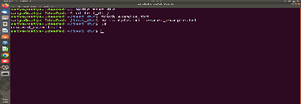

Q-2. Viewing File Contents.Use cat to display the contents of /etc/passwd. Display only the first 5 lines of /etc/passwd using head. Display only the last 5 lines of /etc/passwd using tail.

Ans-2. Viewing File Contents.Use cat = cat /etc/passwd

Display only the first 5 lines = cat /etc/passwd | head -n 5

Display only the last 5 lines = tail -n 5 /etc/passwd

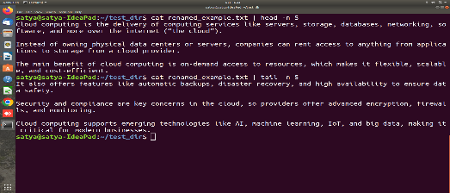

Q-3. Searching for Patterns

Use grep to find all lines containing the word "root" in /etc/passwd.

Ans-3. grep "root" /etc/passwd

Q-4. Zipping and Unzipping

Compress the test_dir directory into a file named test_dir.zip using zip.

Unzip test_dir.zip into a new directory named unzipped_dir.

Ans-4. zip -r test_dir.zip test_dir

mkdir unzipped_dir

unzip test_dir.zip -d unzipped_dir

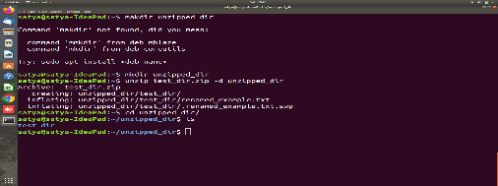 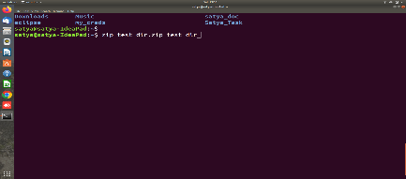

Q-5. Downloading Files

Use wget to download a file from a URL (e.g., https://example.com/sample.txt).

Ans-5. wget https://example.com/sample.txt

Q-6. Changing Permissions

Create a file named secure.txt and change its permissions to read-only for everyone using chmod.

Ans-6. touch secure.txt

chmod 444 secure.txt

Q-7. Working with Environment Variables

Use export to set a new environment variable called MY_VAR with the value "Hello, Linux!".

Ans-7. export MY_VAR="Hello, Linux!"